Drop In Application
Section 1.3 – Design Specification: Low-Level & Section 1.4 – Technical Documentation and Modern Stack

1.3 Design Specification: Low-Level
This section presents the low-level design of Drop In using the C4 model (Context → Container → Component) for system architecture, a UML class diagram for the domain model, and two UML sequence diagrams that trace the same classes through real user journeys. The system is designed API-first: every interaction between the mobile client and the backend, and between backend services themselves, is expressed as a versioned REST contract (JSON over HTTPS), so that services can be developed, tested, and scaled independently (a microservices style).

1.3.1 System Architecture — C4 Model

Level 1 — System Context
At the highest level, Drop In is a single system used directly by MU students and indirectly configured by facility administrators. It depends on three external systems it does not own: the MU Student Database for identity verification, the MU Sports Complex Master Schedule as the authoritative source of court data, and a push-notification provider for real-time alerts.
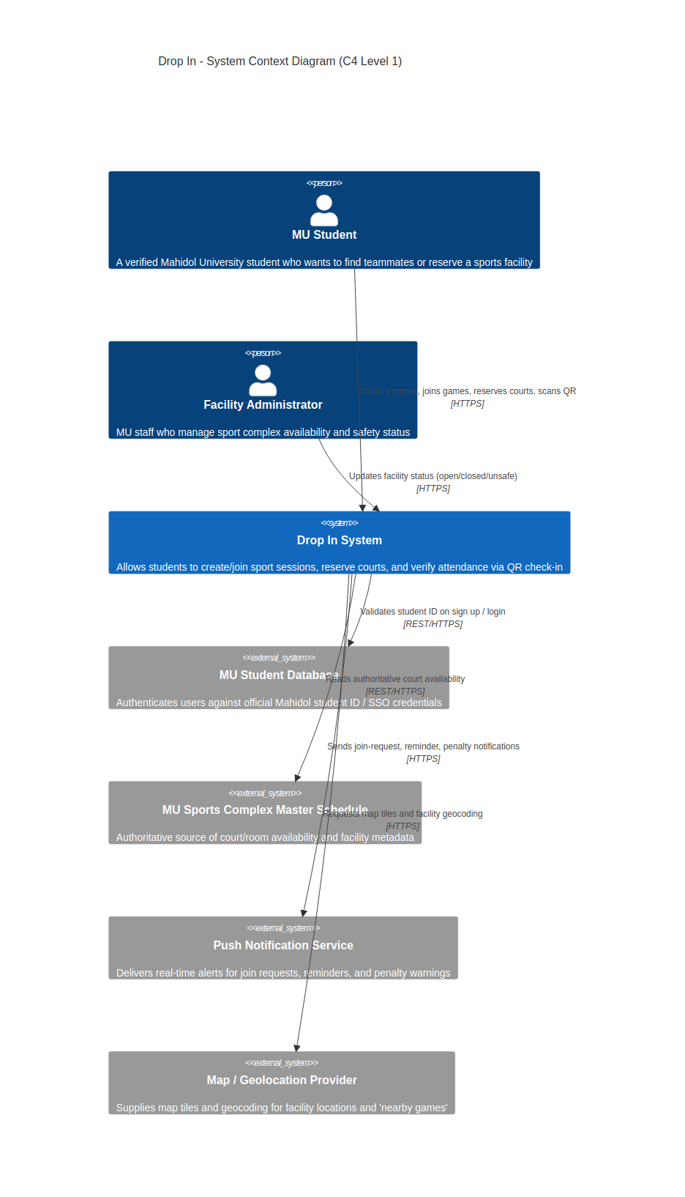
Figure 1.3-1. C4 Level 1 — System Context diagram.

Level 2 — Containers
Drop In is decomposed into independently deployable containers: a Flutter mobile app, a thin API Gateway, and five backend microservices (Auth, Game & Matchmaking, Reservation, QR/Attendance, Notification), each with a single responsibility. A shared MySQL database persists durable state while Redis holds ephemeral, high-frequency state such as live player counts, published over pub/sub so the mobile app can update in real time without polling.
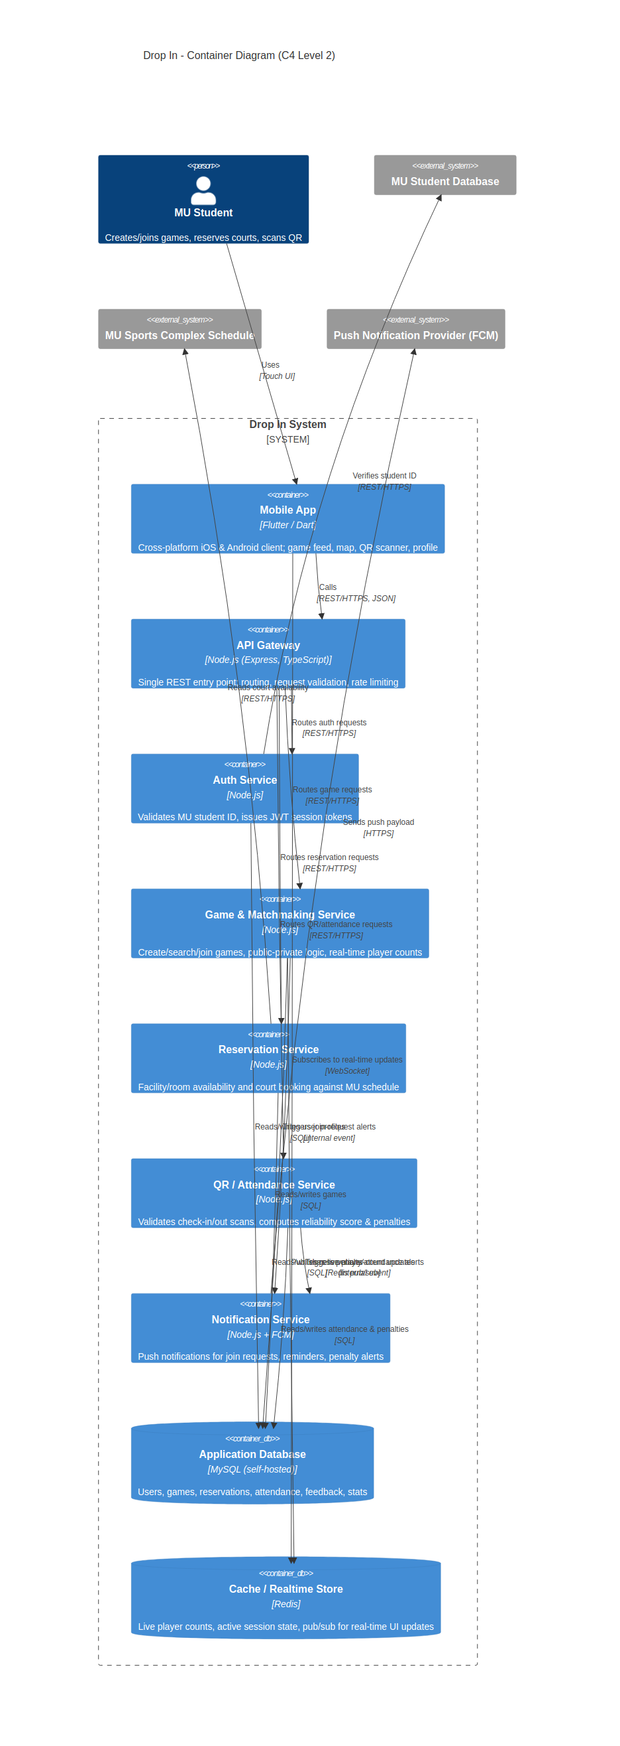
Figure 1.3-2. C4 Level 2 — Container diagram.

Level 3 — Components
Zooming into the Game & Matchmaking Service (the most complex container) shows how its internal components collaborate: a controller layer exposes the REST contract, a service layer enforces business rules (capacity, public/private join logic), a search component ranks results by distance and time, and a repository component isolates persistence behind Prisma ORM so the domain logic never talks to SQL directly.
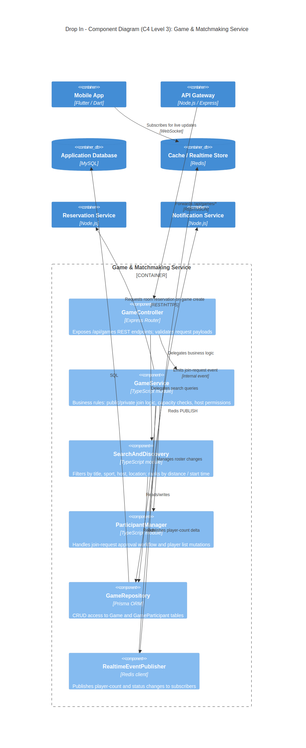
Figure 1.3-3. C4 Level 3 — Component diagram (Game & Matchmaking Service).
We intentionally stop the C4 model at Level 3. Level 4 (Code) is represented instead by the UML class diagram below, since for this project the class diagram already gives full attribute/operation detail without duplicating the same information as a fourth, class-by-class C4 diagram.

1.3.2 Class Diagram
The domain model below is the single source of truth for every entity referenced in the sequence diagrams and the E-R diagram in Section 1.4 — table names, foreign keys and REST payload fields all derive from these classes. Multiplicities capture the real constraints from the SRS: a Game always has exactly one Reservation, a User accumulates zero-or-more PenaltyRecords, and GameParticipant is the associative class that resolves the many-to-many relationship between User and Game (a user can host many games and join many others).
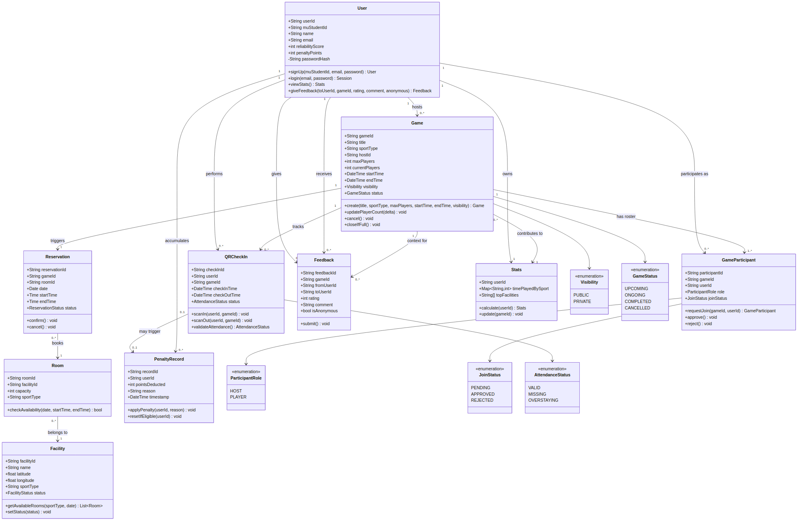
Figure 1.3-4. UML Class Diagram — Drop In domain model.

1.3.3 Sequence Diagrams
Each sequence diagram instantiates the classes above as lifelines/participants, so the class diagram and the sequence diagrams describe the same objects from two complementary views (static structure vs. runtime collaboration).

(a) Create Game & Reserve Facility
Traces FR-2.1–FR-2.3: a host fills in a game, the Game service asks the Facility/Room classes for availability, and a Reservation is confirmed before the Game itself is persisted — guaranteeing a game is never posted without a valid court.
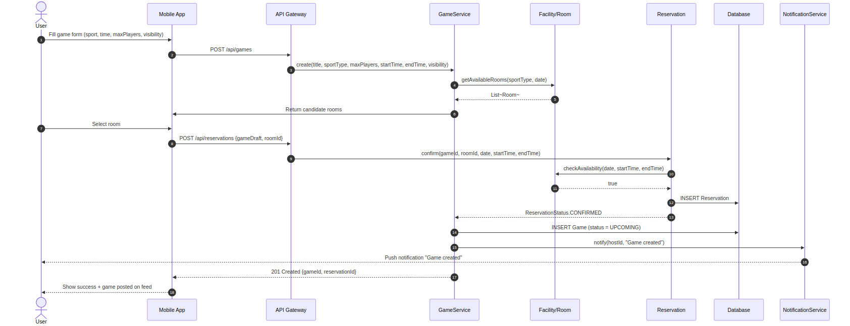
Figure 1.3-5. Sequence diagram — Create Game & Reserve Facility.

(b) Join Game & QR Attendance
Traces FR-2.4, FR-2.5, FR-3.3, FR-3.4, FR-4.1 and FR-4.2: the join path branches on Game.visibility (instant join vs. host-approved GameParticipant), and the attendance path shows QRCheckIn validating both scans before PenaltyRecord is ever created, matching the '3 chances' rule in the SRS.
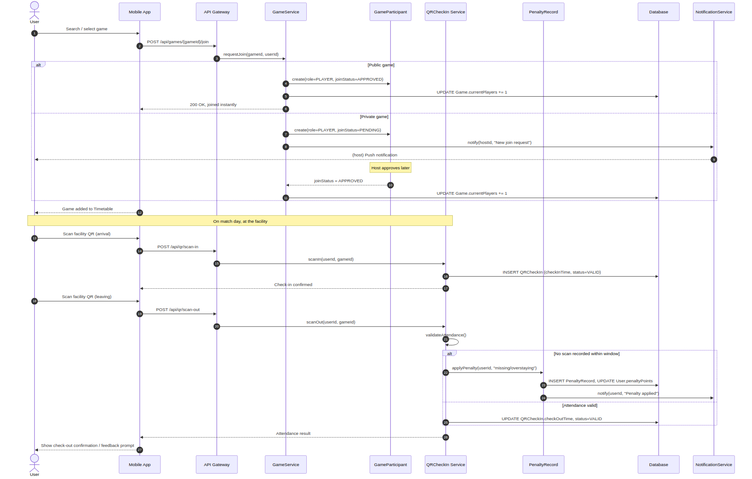
Figure 1.3-6. Sequence diagram — Join Game & QR Attendance.

1.3.4 API-First Design (REST)
Every container in Section 1.3.1 communicates only through documented REST resources — no service reaches into another service's database. Endpoints are versioned under /api/v1 and return JSON; the mobile app is simply the first of potentially several REST clients (a future admin web dashboard could reuse the same contract).
Resource | Method & Path | Owning Service | Purpose
Auth | POST /api/v1/auth/signup | Auth Service | Validate MU student ID, create account
Auth | POST /api/v1/auth/login | Auth Service | Issue JWT session token
Games | POST /api/v1/games | Game & Matchmaking | Create a game (FR-2.1)
Games | GET /api/v1/games?sport=&near=&q= | Game & Matchmaking | Search/filter/discover games (FR-3.1, FR-3.2)
Games | POST /api/v1/games/{id}/join | Game & Matchmaking | Join public game or request private join (FR-2.4/2.5)
Reservations | POST /api/v1/reservations | Reservation Service | Book a room for a game (FR-2.3)
Facilities | GET /api/v1/facilities/{id}/rooms?date= | Reservation Service | Room availability (FR-2.2)
Attendance | POST /api/v1/qr/scan-in | QR/Attendance Service | Check-in scan (FR-4.1)
Attendance | POST /api/v1/qr/scan-out | QR/Attendance Service | Check-out scan & penalty check (FR-4.1, FR-4.2)
Feedback | POST /api/v1/feedback | Game & Matchmaking | Post-game rating/comment (FR-5.1)
Stats | GET /api/v1/users/{id}/stats | Auth Service | Personal statistics (FR-1.2)

1.4 Technical Documentation & Modern Stack
This section lists the concrete tools, languages and environments used to build Drop In, expands the client-only stack from Section 1.5 of the original report with the server-side stack implied by the architecture in Section 1.3, documents the database with an E-R diagram, and explains how the system is containerized for deployment.

1.4.1 System Architecture Stack
Layer | Technology | Rationale
Mobile Client | Flutter (Dart) | Single codebase for iOS & Android; matches team's existing choice in Section 1.5
API Gateway | Node.js + Express (TypeScript) | Lightweight, single REST entry point; large ecosystem, easy to containerize
Backend Services | Node.js (TypeScript), one process per service | Matches API-first/microservices design in Section 1.3.1
ORM | Prisma | Type-safe access to MySQL from TypeScript services
Primary Database | MySQL 8 (self-hosted within the university) | Relational integrity for users, games, reservations — same choice as original report
Cache / Realtime | Redis 7 (pub/sub) | Sub-100ms player-count updates required by NFR-1.3
Auth | JWT sessions, validated against MU Student Database | Required by FR-1.1
Push Notifications | Firebase Cloud Messaging (FCM) | Cross-platform push for join requests & penalty alerts
IDE / Emulation | VS Code, Android Studio (SDK/Emulator) | Carried over from original tool selection
Version Control | Git & GitHub | Carried over from original tool selection
Containerization | Docker + Docker Compose (Kubernetes-ready) | See Section 1.4.3

1.4.2 Database & E-R Diagram
The relational schema mirrors the class diagram in Section 1.3.2 one-for-one: each class becomes a table, each association becomes a foreign key (or a junction table for many-to-many, e.g. GAME_PARTICIPANT), and enumerated class attributes such as Visibility, GameStatus, JoinStatus and AttendanceStatus become constrained string/enum columns.
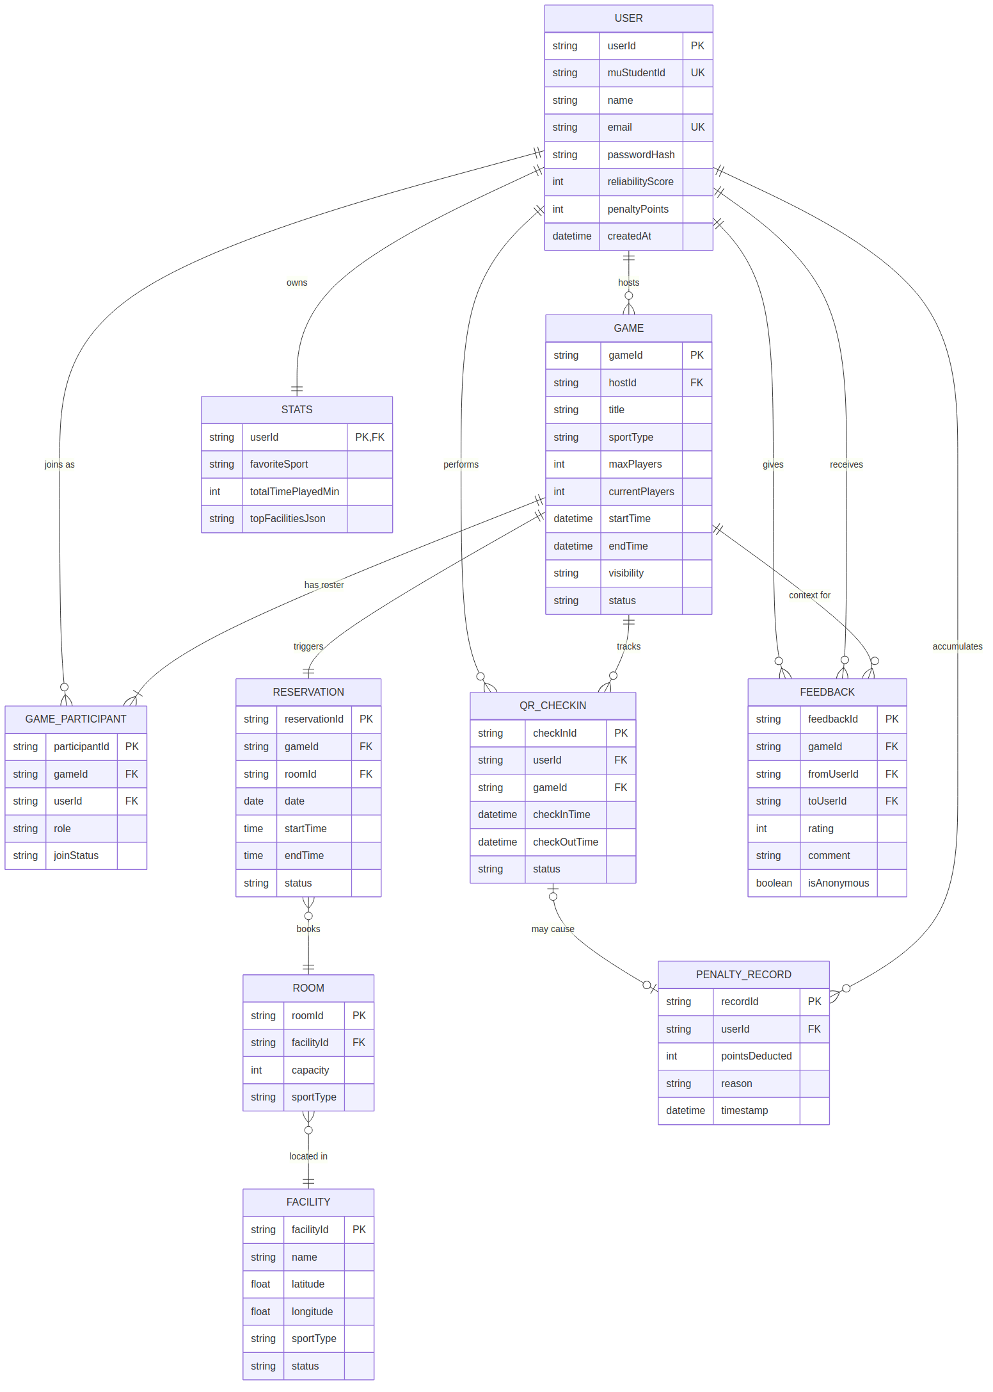
Figure 1.4-1. Entity-Relationship diagram — Drop In database.

1.4.3 Containerization
Each backend service is packaged as its own lightweight Docker image so it can be built, tested, scaled and redeployed independently — a direct consequence of the container boundaries drawn in Section 1.3.1.
- Base image: node:20-alpine keeps each service image small (~120MB) and starts quickly.
- Multi-stage build: an initial 'builder' stage runs npm ci && npm run build (TypeScript → JS); the final stage copies only the compiled dist/ and production node_modules, so devDependencies never ship.
- Each service exposes one internal port (e.g., 3001–3005) and reads configuration (DB_URL, REDIS_URL, JWT_SECRET) from environment variables injected at runtime, never baked into the image.
- docker-compose.yml wires the API Gateway, five services, MySQL, and Redis on a private bridge network; MySQL's data directory is mounted as a named volume (mysql-data) so data survives container restarts.
- For staging/production the same images are pushed to a registry and rolled out on Kubernetes (or plain Docker Swarm) using the container boundaries as the Pod/Deployment boundaries, enabling independent horizontal scaling — e.g., Game & Matchmaking can be scaled to more replicas than Notification during peak hours.
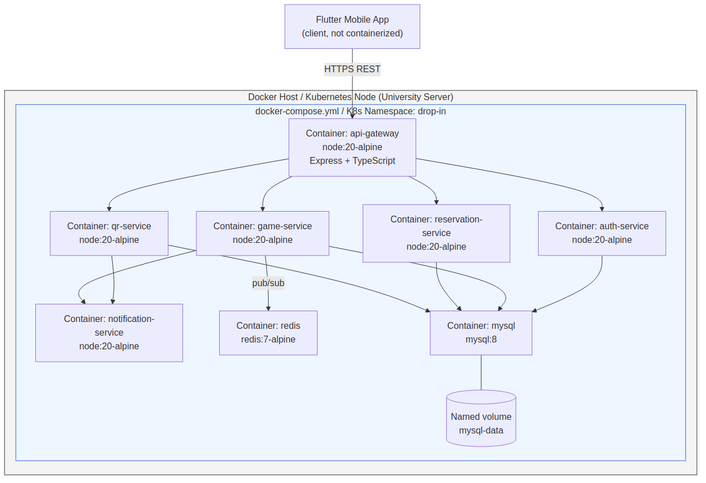
Figure 1.4-2. Containerization diagram — Docker services and volumes.

1.4.4 AI Integration: Generating the Initial Data Schema
Once the class diagram (Section 1.3.2) was finalized, we used an AI assistant to draft the first-pass SQL/Prisma schema from it rather than hand-writing every table, which sped up bootstrapping and reduced simple mistakes such as forgetting a foreign key or nullable constraint.
- Prompt given to the AI: "Given this UML class diagram (classes, attributes, and multiplicities pasted below), generate a normalized Prisma schema with primary keys, foreign keys, and enum types for Visibility, GameStatus, JoinStatus and AttendanceStatus."
- The AI-generated schema was then manually reviewed against the SRS: reliabilityScore/penaltyPoints placement on User, the mandatory 1-to-1 link between Game and Reservation, and the NFR-3.3 rule that live location must never be persisted or shared.
- Corrections made by the team: added a composite unique index on (userId, gameId) in QR_CHECKIN to prevent duplicate check-ins, and split Stats into its own table instead of denormalizing it onto User, to keep write-heavy attendance updates separate from read-heavy profile lookups.
This mirrors the AI-assisted workflow already used for the Product Backlog and prototype heat-maps elsewhere in the report: AI accelerates the first draft, and the team retains responsibility for validating it against the requirements.

